| List 4 Different Markets/Industries | Pure/Perfect Competition | Monopolistic Competition | Oligopoly | Pure Monopoly |
| --- | --- | --- | --- | --- |

3 Ways Consumers Benefit From Businesses Competing Against Each Other

| **Reason** | **Explanation** |
| --- | --- |
| Keeps prices low | When business compete, companies want more people to buy, so lessen the price to increase the demand for that products |
| It makes the quality of that good or service good and high | When businesses compete, companies want to increase the quality of that good or service so more people would wanna buy them, better quality higher demand |
| More innovative products | When businesses compete, more people would want to create more innovative and advanced products so they can raise more money from more com |

Recreate the Market Structures in the Text Boxes Below

| Perfect Competition | Monopolistic Competition | Oligopoly | Pure Monopoly |
| --- | --- | --- | --- |
| Many Competitors |  |  | Complete competition |

Perfect/Pure Competition

Most Amount of competitors

| **Characteristic #1** | **Explanation** |
| --- | --- |
| Many buyers and sellers act independently | No single buyer or seller in a market has enough power to control demand, supply, or prices |

| **Characteristic #2** | **Explanation** |
| --- | --- |
| Sellers offer identical products | Buyers choose one product over another primarily on price, not unique characteristics |

| **Characteristic #3** | **Explanation** |
| --- | --- |
| Sellers can enter or exit the market easily | Sellers must be able to enter a profitable market --- or leave an unprofitable one-easily. This ensures that a single seller cannot dominate a particular market. Few Barriers to Entry |

| Define “Barriers To Entry” | Factors that keep competition from enter a market/industry |
| --- | --- |

Provide & Explain 3 Reasons Why Starting A Cell Phone Service Company Will Likely Fail

| **Reason** | **Explanation** |
| --- | --- |
| Massive Customer Loyalty | Many customers are loyal to their current phone service and have not switched their phone service before |
| To many competitors | More people would wanna start competing with you more so you wouldn be raising that much money |
| Not enough start up costs | It costs a lot of money to start up a phone service company. Many peop;e don't have enough money to start those type of companies, you need to pay for the resources which are hard to find and too expensive |

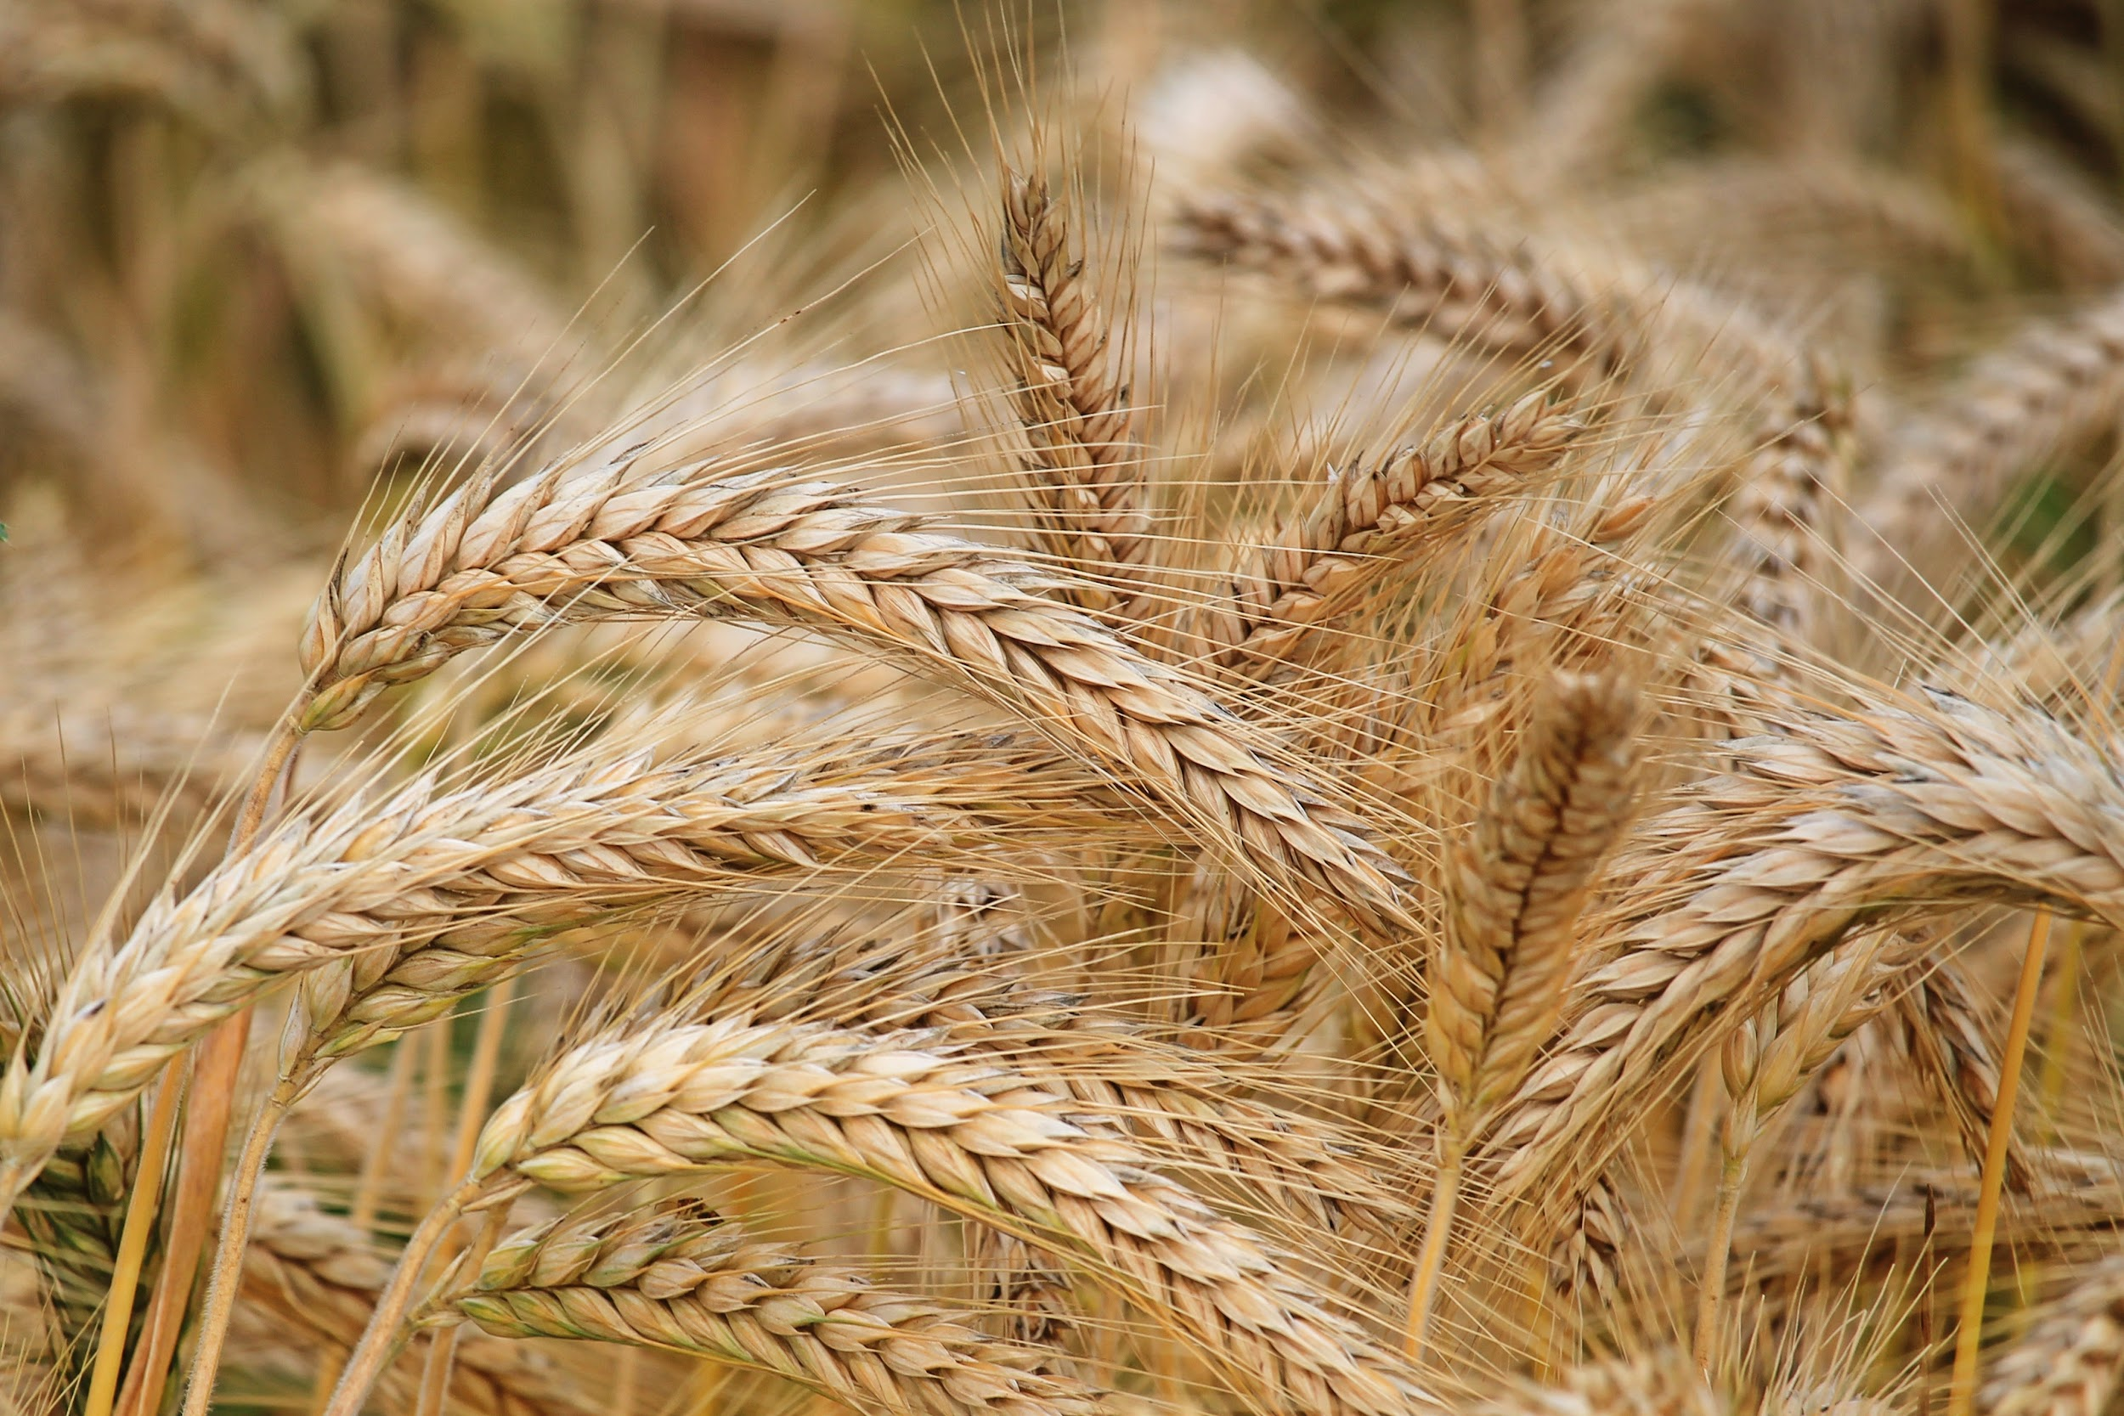

Explain the 3 reasons why wheat is one of the best examples of Perfect/Pure Competition

| Thousands of independent farmers compete to sell their products to millions of buyers |
| --- |
| For the most part, products are identical |
| Farmers who already own land can switch to different products |

Monopolistic Competition

| **Key Difference Between Monopolistic Competition & Perfect Competition** | **Explanation** |
| --- | --- |
| Sellers offer similar, rather than identical products | It means that can be used for the use of things but they are not the exact same type or product of each other. You have to lower prices to get more customers and easier to get. They are looking to vary their  Each firm seeks to have a monopoly-like power by selling a unique product- product variation  Product variation is more common than having identical products.Sellers try to differentiate or point out differences(real or merely seem real), between their products and those of their competitors |

| **What are businesses hoping to avoid with product variation?** |
| --- |
| You purchase the lowest price product, they want you to be willing to pay a higher price.Sellers here compete on a basis other than price. They compete through advertising by emphasizing their brand names. They want less people. |

| **Ways Shoe Companies Differentiate Their Shoes** | **Explanation** | **Insert Photo Of Your Example** |
| --- | --- | --- |
| 1)Different Shoe Colors | Shoe companies can change/varrie different colors of their shoe products because people would want different colors | Different color shoes, the new trend |
| 2)Different shoe styles | Companies want to vary the style of the shoe from high heeled to low heeled shoes because people have different preferences. | Types of Shoes: Useful List of Shoes with Pictures • 7ESL |
| 3)Different traction of shoes | Companies want to vary the traction of shoes because some people have to have different traction of shoes like snow shoes | Inside Access: The Science of Traction - Nike News |
| 4)Different securements of shoes | Companies would want to vary the securements of the shoe such as having some shoes have velcro or laces, people have different preferences | Kids' Sneakers: Velcro Fasteners vs Shoelaces - VersusBattle.com |
| 5)Different materials | Materials like leather and plastic are used to build shoes, companies need to vary their materials used because some people want shoes that last long or last a short tie | Shoes Materials Symbols Footwear Labels Shoes Properties Glyph Stock  Illustration - Download Image Now - iStock |
| 6)Different functions | May companies need to have different shoes that have different functions like running and basketball shoes, if they have the same shoe function, some people many have trouble running or playing basketball so they | Basketball shoes vs Running shoes | Shoesblast.com | August 2021 |